Gyro Rate Investigation

Abstract

An approximate peak angular velocity of a rocket in flight was required for selecting rate gyros for the planned inertial measurement unit. By setting up an airframe in the wind tunnel the response to random force inputs was measured using a potentiometer encoder and an ADXRS150 rate gyro. The maximum angular velocity recorded was 112.9°/s. The accuracy of this value was unknown and to be used only as a rough guide.

Intro

In order to select gyros suitable for the IMU, approximate data was required for the rotational acceleration of the rocket. To obtain the data, an airframe of similar geometry to the final rocket was constructed and tested in the wind tunnel.

Method

A rocket airframe was constructed from a dia. 90mm cardboard tube 1.1m in length, with a conical nose cone and plywood fins. The assembly was mounted on bearings on a vertical shaft passing through the approximate centre of gravity of the airframe. A flap was included on one of the vertical fins actuated by a servo with associated radio control equipment. This gave the capacity to give the rocket a disturbance input while in the wind tunnel to simulate the rockets motion. An ADXRS150 rate gyro and potentiometer encoder were mounted on the airframe to determine the approximate angular velocities experienced by the rocket. Data was logged using a 2 channel USB oscilloscope that read in the analogue outputs from the rate gyro and encoder.

Calibration of the encoder and gyro was carried out by rotating the airframe through 90° and analysing the output. For the encoder, as the angle of rotation was proportional to the voltage change, a linear model developed to convert the voltage output into an angle. Angular velocity was obtained by differentiating the angel with respect to time, and applying a filter. The gyro output was converted to angular rate by averaging the voltage shift from the steady state value over the swing from 0° to 90°, and applying a linear fit. The analysis spreadsheet used can be found on the svn repository.

Results

Due to data corruption, simultaneous readings of encoder and gyro were not obtained from the wind tunnel test. The conversion from gyro voltage output to angular rate was obtained in later bench tests, and one set of wind tunnel data was converted. The results are shown in Figure 1. The maximum acceleration recorded was 112.9°/s.

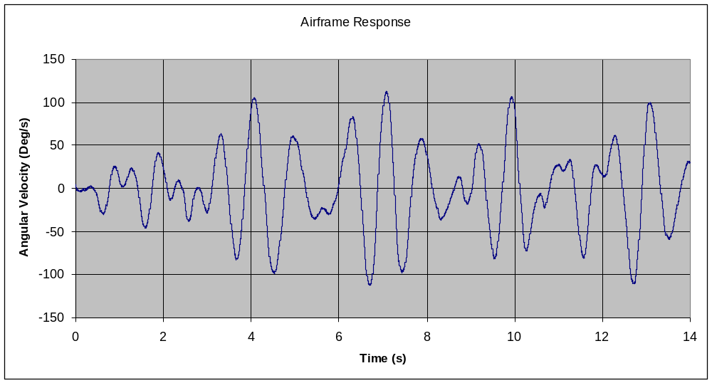
Figure 1: Airframe response to various control surface inputs in the wind tunnel at 60km/h

Discussion

While the air velocity in the wind tunnel was much less than that of the actual rocket, the rotational inertia was also less. As higher velocities would increase the peak angular velocities and higher inertia would have a reducing effect, some cancellation would occur. These results only give a ballpark idea of the dynamics the final rocket control system would need to cope with. If the resolution range of the gyros being selected is too close to the peak angular velocity measured, further investigation should be carried out.

Conclusion

A rough indication of the peak angular velocity expected of the rocket was determined from the wind tunnel test. Selection of the gyros based on these results must take into account the dissimilar setup to the final planned airframe.

Work performed by: Malcolm Snowdon and Alex Keall.
Report written by: Malcolm Snowdon
Date completed: 31/07/09

